**Ideation Phase**

**Define the Problem Statements**

|  |  |
| --- | --- |
| Date | 18 October 2022 |
| Team ID | PNT2022TMID52672 |
| Project Name | Project -A novel method for handwritten digit recognition |
| Maximum Marks | 2 Marks |

**PROBLEM STATEMENT - 1**

**Handwritten digit recognition system used in Banking sectors**

This system can be used to overcome the following issues:

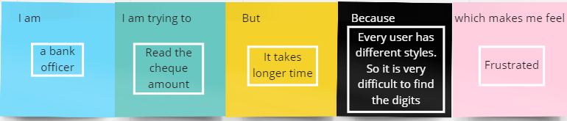

**PROBLEM STATEMENT - 2**

**Handwritten digit recognition system used in postal system**

This system can be used to overcome the following issues:

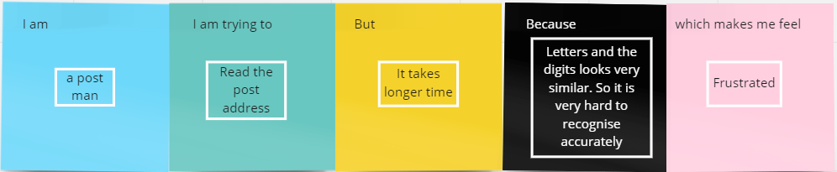

|  |  |  |  |  |  |
| --- | --- | --- | --- | --- | --- |
| **Problem Statement (PS)** | **I am (Customer)** | **I’m trying to** | **But** | **Because** | **Which makes me feel** |
| PS-1 | a post man | Read the post address | It takes a long time | Letters and the digits looks very similar. So it is very hard to recognise  accurately. | Frustrated |
| PS-2 | a bank officer | Read the cheque amount | It takes a long time | Every user has different styles. So it is very difficult to find the digits | Frustrated |